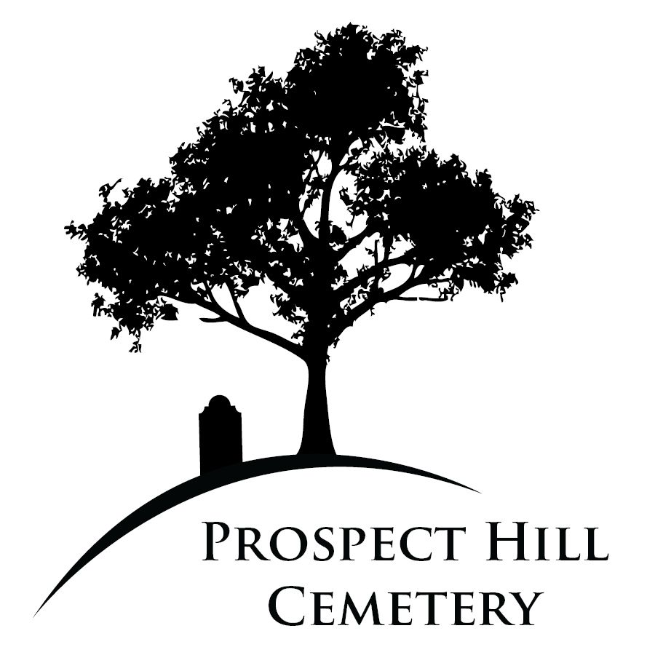

Property Administrator Search for Prospect Hill Cemetery of Towson, Inc.
Prospect Hill Cemetery (PHC), an historic and active cemetery in Towson, Maryland, is conducting a search for an independent contractor to serve as a part-time Administrator. We seek someone who is well organized and able to independently manage/execute the daily operations of PHC. Candidate’s knowledge of, interest in, and proximity to Towson is important.

Historic Prospect Hill Cemetery is a six-acre non-sectarian cemetery on York Road in the heart of Towson. More than 3,000 people are buried at PHC. Many of the families who built and shaped Towson, Baltimore County, and the nation, rest here. PHC has been an active cemetery business since 1892. Today, it remains an independent, non-denominational, non-profit cemetery managed by an all-volunteer Board of Directors. PHC still has lots available to purchase for future generations; it relies on charitable donations to sustain daily operations.
Administrator Position
For 40 years, The Board of Directors has overseen the restoration, improvement, and management of PHC. After 20 years, Board President Carolyn Knott is preparing to transition her administrative duties to an independent contractor and the Board. While lot sales will continue to be managed by Ms. Knott in the near term, this duty will eventually become the Administrator’s responsibility.
Direct experience as an Administrator is essential. The position is external facing. The right candidate must enjoy working with people; this includes families, board members, local institutions/businesses, and community leaders. The Administrator’s role involves the day-to-day operations of the cemetery and coordination with Board members. The position will require an average of approximately 20 hours of work per week.
PHC is open to discussing worksite arrangements.
Supported by the Board of Directors (and relevant committees) PHC’s Administrator will:
- manage cemetery operations, oversee care of the burial grounds
- schedule and coordinate lot sales and burials: average annual lot sales are 8-10 and burials are 15-20
- collaborate with PHC team to maintain burial records (some historic/manual), update lot ownership
- process mail, donations; general filing, check voicemail and emails daily
- attend in-person quarterly Board meetings, and up to two monthly committee meetings
- maintain CRM database and support marketing and fundraising administrative activities
- manage volunteers and strategic partners

Ideal Candidate Skills
The candidate should clearly demonstrate the following skills and expect the identified tasks. Some tasks will be required on a weekly basis; others will be occasional.

- Administration. Demonstrated proficiency in Microsoft Office, CRM donor management systems, cloud-based record keeping, data entry; ability to process mail, donations.

- Communications. Good communication and writing skills and an ability to draft quarterly meeting minutes.

- Project Management. Ability to coordinate property management contractors; record lot sales and burials; manage volunteers at occasional events; coordinate with board committees.

- Development. Willingness to support fundraising activities; process annual mailing and acknowledgments; administratively support relevant Board members in donor identification and cultivation; support Capital Campaign; assist with grant pursuits.

- Collaboration. Willingness to collaborate with an engaged board of directors; connect and network with stakeholder groups, individuals, institutions and communities.

Compensation

The Administrator will be compensated as an independent contractor working an average of 20 hours per week at an hourly rate to be determined.

Express Interest in the Opportunity
Please submit a cover letter outlining the skills, professional and life experience you would bring to this opportunity along with your resume and three references to admin@prospecthilltowson.org.
PHC is an equal opportunity business, committed to diversity and inclusion.

